

EVB-LAN9255 – EtherCAT SIP Counter FOE firmware Release Notes

|  |  |  |  |
| --- | --- | --- | --- |
| Microchip Technology, Inc. | | | Microchip Technology, Incorporated  2355 W. Chandler Boulevard  Chandler, Arizona 85224  480/792-7416 |
| REV | DATE | ORIGINATOR | DESCRIPTION OF CHANGE |
| 1.0 | 9/29/2020 | Rathika K | Initial version |
| 1.01 | 12/01/2020 | Rathika K | Bug Fix Release for Compliance Failure |
| 1.02 | 12/11/2020 | Rathika K | OLED support |
| 1.03 | 1/07/2021 | Rathika K | Bug Fix Release |
| 1.04 | 1/27/2021 | Venkata Durga Prasad | UART Support |
| 1.05 | 2/18/2021 | Venkata Durga Prasad | Bug Fix release |
| 1.06 | 3/23/2021 | Venkata Durga Prasad | Bug Fix Release |
| 1.07 | 4/4/2021 | Rathika K | Reduced time delay taken to update alias register |
| 1.08 | 4/26/2021 | Rathika K | Bug Fix Release |
| 1.09 | 6/15/2021 | Venkata Durga Prasad | New device id support and updated readme file as per new device id. |
| 1.10 | 6/17/2021 | Rathika K | Changes from 1.2 to 1.3 |

Table of Contents

1 Introduction 5

2 Legal Information 5

3 Terms and abbreviations 6

4 Prerequisites 6

5 References 6

6 Release notes 7

6.1 Version 1.3 7

6.1.1 Not implemented / Limited functionality requirements 7

6.1.2 Bug Fixes 8

6.1.3 Features added. 8

6.2 Version 1.2 8

6.2.1 Not implemented / Limited functionality requirements 9

6.2.2 Bug Fixes 10

6.2.3 Features added. 10

6.3 Version 1.1 10

6.3.1 Not implemented / Limited functionality requirements 10

6.3.2 Bug Fixes 12

6.3.3 Features added. 12

6.4 Version 1.0 12

6.4.1 Not implemented / Limited functionality requirements 12

6.4.2 Bug Fixes 13

6.4.3 Features added 13

6.5 Version 0.92 13

6.5.1 Not implemented / Limited functionality requirements 13

6.5.2 Bug Fixes 14

6.5.3 Features added 14

6.6 Version 0.91 15

6.6.1 Not implemented / Limited functionality requirements 15

6.6.2 Bug Fixes 16

6.6.3 Features added 16

6.6.4 Notes 17

6.7 Version 0.9 18

6.7.1 Not implemented / Limited functionality requirements 18

6.7.2 Bug Fixes 18

6.7.3 Features added 18

6.7.4 Notes 18

6.8 Version 0.8 21

6.8.1 Not implemented / Limited functionality requirements 21

6.8.2 Bug Fixes 21

6.8.3 Features added 21

6.8.4 Notes 22

6.9 Version 0.7 23

6.9.1 Not implemented / Limited functionality requirements 23

6.9.2 Bug Fixes 23

6.9.3 Features added 23

6.9.4 Notes 23

6.10 Version 0.51 24

6.10.1 Not implemented / Limited functionality requirements 24

6.10.2 Bug Fixes 24

6.10.3 Features added 24

6.10.4 Notes 25

6.11 Version 0.5 26

6.11.1 Not implemented / Limited functionality requirements 26

6.11.2 Bug Fixes 26

6.11.3 Features added 26

6.11.4 Notes 27

# Introduction

|  |  |
| --- | --- |
| Component Type | Firmware Framework |
| **Target Silicon** | LAN9255 |
| **Where can an end user see the version number** |  |

This document contains the EVB- LAN9255 EtherCAT Device Controller SDK – SAME53 Counter FOE firmware samples based on EVB-LAN9255-SQI platform.

# Legal Information

Information contained in this publication regarding device applications and the like is provided only for your convenience and can be superseded by updates. It is your responsibility to ensure that your application meets with your specifications. MICROCHIP MAKES NO REPRESENTATIONS OR WARRANTIES OF ANY KIND WHETHER EXPRESS OR IMPLIED, WRITTEN OR ORAL, STATUTORY OR OTHERWISE, RELATED TO THE INFORMATION, INCLUDING BUT NOT LIMITED TO ITS CONDITION, QUALITY, PERFORMANCE, MERCHANTABILITY OR FITNESS FOR PURPOSE**.**

Microchip disclaims all liability arising from this information and its use. Use of Microchip devices in life support and/or safety applications is entirely at the buyer’s risk, and the buyer agrees to defend, indemnify and hold harmless Microchip from any and all damages, claims, suits, or expenses resulting from such use. No licenses are conveyed, implicitly or otherwise, under any Microchip intellectual property rights.

**Trademarks**

The Microchip name and logo, the Microchip logo, dsPIC, FlashFlex, flexPWR, JukeBlox, KEELOQ, KEELOQ logo, Kleer, LANCheck, MediaLB, MOST, MOST logo, MPLAB, OptoLyzer, PIC, PICSTART, PIC32 logo, RightTouch, SpyNIC, SST, SST Logo, SuperFlash and UNI/O are registered trademarks of Microchip Technology Incorporated in the U.S.A. and other countries.

The Embedded Control Solutions Company and mTouch are registered trademarks of Microchip Technology Incorporated in the U.S.A.

Analog-for-the-Digital Age, BodyCom, chipKIT, chipKIT logo, CodeGuard, dsPICDEM, dsPICDEM.net, ECAN, In-Circuit Serial Programming, ICSP, Inter-Chip Connectivity, KleerNet, KleerNet logo, MiWi, MPASM, MPF, MPLAB Certified logo, MPLIB, MPLINK, MultiTRAK, NetDetach, Omniscient Code Generation, PICDEM, PICDEM.net, PICkit, PICtail, RightTouch logo, REAL ICE, SQI, Serial Quad I/O, Total Endurance, TSHARC, USBCheck, VariSense, ViewSpan, WiperLock, Wireless DNA, and ZENA are trademarks of Microchip Technology Incorporated in the U.S.A. and other countries.

SQTP is a service mark of Microchip Technology Incorporated in the U.S.A.

Silicon Storage Technology is a registered trademark of Microchip Technology Inc. in other countries.

GestIC is a registered trademarks of Microchip Technology Germany II GmbH & Co. KG, a subsidiary of Microchip Technology Inc., in other countries.

All other trademarks mentioned herein are property of their respective companies.

© 2015, Microchip Technology Incorporated, Printed in the U.S.A., All Rights Reserved.

EtherCAT® is registered trademark and patented technology, licensed by Beckhoff Automation GmbH, Germany.

# Terms and abbreviations

IDE - Integrated Development Environment

ESC - EtherCAT Slave Controller

EVB - Engineering Validation Board

SQI - Serial Quad I/O Interface

SSC - Slave Stack Code

ESF - EtherCAT Software Framework

# Prerequisites

The following development tools are required for using this sample for developing EtherCAT application:

* MPLAB IDE v5.35 or above

(Refer to MPLAB IDE download link: <http://www.microchip.com/pagehandler/en-us/family/mplabx/>)

* MPLAB XC32 Compiler v3.01 or above

(Refer to MPLAB XC Compiler download link: <http://www.microchip.com/pagehandler/en-us/devtools/mplabxc/home.html>)

* EVB-LAN9255 Counter FOE firmware for SQI from Microchip.
* SSC v5.12 code from EtherCAT.org.

Note: *For using this slave stack code (SSC), you need to be a member of EtherCAT.org.*

* MPLAB IPE V5.35 or above

(Refer to MPLAB IPE download link: <http://microchip.wikidot.com/ipe:installation>)

* TwinCAT 3.11 or above.

(Refer to Beckhoff site to download TwinCAT <http://beckhoff.com> )

* LAN9255DFP v1.1.7 or above

Refer Microchip DFP packs support.

* PICkit4_TP v1.9.1151 or above

Refer Miicrochip tool packs support.

# References

* Jutland Switches and Industrial Controllers DOS - <http://mchpweb:4576/Fileattach/SpecIndex/DOS1700119/DOS-02606c.pdf>

# Release notes

## Version 1.3

|  |  |
| --- | --- |
| Release date | 6/17/2021 |
| **Release Type** | Beta |
| **Pre-requisites (if any)** | No |
| **Source code path** | https://bitbucket.microchip.com/scm/ung_apps/lan9255_firmware_applications.git |
| **Source code label / branch & perforce change list number** | Tag: COUNTER_FOE_UART_V1.3 |
| **Software Requirements Specification (SRS) Path and Revision Number** | NA |
| **Software Design Document (SDD) Path and Revision Number** | NA |
| **Software Developer Test Plan (SDTP) Path and Revision Number** | //depot_hw_jutland2_MCM/doc/sw/TestPlan/LAN9255-SAME53-ETHERCAT-COUNTER-FOE_Developer_Test Report.xlsm |
| **Software Requirements Tracker (SRT) Path and Revision Number** | NA |

### Not implemented / Limited functionality requirements

None

### Bug Fixes

None

### Features added.

* Macros added to differentiate counter and IO DC related configurations.

Notes:

* MPLAB IDE and IPE version required 5.35 or above.
* LAN9255 DFP v1.1.7 or above
* PICkit4_TP v1.9.1151 or above

## Version 1.2

|  |  |
| --- | --- |
| Release date | 6/15/2021 |
| **Release Type** | Beta |
| **Pre-requisites (if any)** | No |
| **Source code path** | https://bitbucket.microchip.com/scm/ung_apps/lan9255_firmware_applications.git |
| **Source code label / branch & perforce change list number** | Tag: COUNTER_FOE_UART_V1.2 |
| **Software Requirements Specification (SRS) Path and Revision Number** | NA |
| **Software Design Document (SDD) Path and Revision Number** | NA |
| **Software Developer Test Plan (SDTP) Path and Revision Number** | //depot_hw_jutland2_MCM/doc/sw/TestPlan/LAN9255-SAME53-ETHERCAT-COUNTER-FOE_Developer_Test Report.xlsm |
| **Software Requirements Tracker (SRT) Path and Revision Number** | NA |

### Not implemented / Limited functionality requirements

None

### Bug Fixes

None

### Features added.

* Added New device ID support. Updated the project configurations as per the new device ID and updated the requirements section as per the new device ID.

Notes:

* MPLAB IDE and IPE version required 5.35 or above.
* LAN9255 DFP v1.1.7 or above
* PICkit4_TP v1.9.1151 or above

## Version 1.1

|  |  |
| --- | --- |
| Release date | 4/26/2021 |
| **Release Type** | Feature |
| **Pre-requisites (if any)** | No |
| **Source code path** | https://bitbucket.microchip.com/scm/ung_apps/lan9255_firmware_applications.git |
| **Source code label / branch & perforce change list number** | bugfix/UNG_J2_SIP-69  Tag: COUNTER_FOE_UART_V1.1 |
| **Software Requirements Specification (SRS) Path and Revision Number** | NA |
| **Software Design Document (SDD) Path and Revision Number** | NA |
| **Software Developer Test Plan (SDTP) Path and Revision Number** | //depot_hw_jutland2_MCM/doc/sw/TestPlan/LAN9255-SAME53-ETHERCAT-COUNTER-FOE_Developer_Test Report.xlsm |
| **Software Requirements Tracker (SRT) Path and Revision Number** | NA |

### Not implemented / Limited functionality requirements

None

### Bug Fixes

* UNG_J2_SIP-69 – FOE feature is not working with mode switching.

### Features added.

* None

## Version 1.0

|  |  |
| --- | --- |
| Release date | 4/4/2021 |
| **Release Type** | Feature |
| **Pre-requisites (if any)** | No |
| **Source code path** | https://bitbucket.microchip.com/scm/ung_apps/lan9255_firmware_applications.git |
| **Source code label / branch & perforce change list number** | feature/eeprom_emulation_time_delay_reduction  Tag: COUNTER_FOE_UART_V1.0 |
| **Software Requirements Specification (SRS) Path and Revision Number** | NA |
| **Software Design Document (SDD) Path and Revision Number** | NA |
| **Software Developer Test Plan (SDTP) Path and Revision Number** | //depot_hw_jutland2_MCM/doc/sw/TestPlan/LAN9255-SAME53-ETHERCAT-COUNTER-FOE_Developer_Test Report.xlsm |
| **Software Requirements Tracker (SRT) Path and Revision Number** | NA |

### Not implemented / Limited functionality requirements

None

### Bug Fixes

* UNG_J2_SIP-69 – FOE feature is not working.

### Features added

* UNG_J2_SIP-72 - Reduce time taken to update alias register in the EtherCAT firmware application.

## Version 0.92

|  |  |
| --- | --- |
| Release date | 3/23/2021 |
| **Release Type** | Bug Fix |
| **Pre-requisites (if any)** | No |
| **Source code path** | https://bitbucket.microchip.com/scm/ung_apps/lan9255_firmware_applications.git |
| **Source code label / branch & perforce change list number** | feature/ethercat_uart  Tag: COUNTER_FOE_UART_V0.92 |
| **Software Requirements Specification (SRS) Path and Revision Number** | NA |
| **Software Design Document (SDD) Path and Revision Number** | NA |
| **Software Developer Test Plan (SDTP) Path and Revision Number** | //depot_hw_jutland2_MCM/doc/sw/TestPlan/LAN9255-SAME53-ETHERCAT-COUNTER-FOE_Developer_Test Report.xlsm |
| **Software Requirements Tracker (SRT) Path and Revision Number** | NA |

### Not implemented / Limited functionality requirements

None

### Bug Fixes

* J2-SIP-41 - Dynamic UART Transfer Bit Configuration was not Effective.
* J2-SIP-28 - EVB_LAN9255_Counter_Direct_Mode_EEPROM_Emulation Firmware did not drive the OLED Display in EVB
* J2-SIP-66 - FOE of Direct/Indirect bin file Fails when FOEed Direct Firmware Serves as a Base

### Features added

None

## Version 0.91

|  |  |
| --- | --- |
| Release date | 2/18/2021 |
| **Release Type** | Bug Fix |
| **Pre-requisites (if any)** | No |
| **Source code path** | https://bitbucket.microchip.com/scm/ung_apps/lan9255_firmware_applications.git |
| **Source code label / branch & perforce change list number** | feature/ethercat_uart  Tag: COUNTER_FOE_UART_V0.91 |
| **Software Requirements Specification (SRS) Path and Revision Number** | NA |
| **Software Design Document (SDD) Path and Revision Number** | NA |
| **Software Developer Test Plan (SDTP) Path and Revision Number** | //depot_hw_jutland2_MCM/doc/sw/TestPlan/LAN9255-SAME53-ETHERCAT-COUNTER-FOE_Developer_Test Report.xlsm |
| **Software Requirements Tracker (SRT) Path and Revision Number** | NA |

### Not implemented / Limited functionality requirements

None

### Bug Fixes

* J2-SIP-35 - EVB_LAN9255_Counter_InDirect_Mode_EEPROM_Emulation V0.90 Firmware was Unstable.
* J2-SIP-36 - Documentation on EtherCAT Counter Application (UART) V0.90
* J2-SIP-37 - UART Read Buffer Skips the First character and Displays the Second character
* J2-SIP-38 - EtherCAT Slave Device goes to Error State when UART Write is Performed
* J2-SIP-39 - Dynamic UART Baud Rate Configuration Failure in EVB_LAN9255_Counter_EEPROM_Emulation V0.90 Firmware
* J2-SIP-40 - Maximum Supported data Size in UART Data Transmission
* J2-SIP-41 - Dynamic UART Transfer Bit Configuration was not Effective.

### Features added

None

### Notes

* The PDI frequency can be selected through the ESF configuration file. The frequency can be given in Mhz to ESF_PDI_FREQUENCY.
* By default, the EEPROM emulation is enabled, can be disabled by commenting **_IS_EEPROM_EMULATION_SUPPORT** macro present in **ESF_Config.h** file.
  + For reference



* **SSC code Generation for EEPROM Emulation mode** – There are two steps to be followed while generating the SSC code for EEPROM Emulation mode and are as follows.
  + The ESC_EEPROM_EMULATION must be 1 and ESC_EEPROM_CONTENT must be 1, while generating SSC code and copy the eeprom.h file and place it in SSC folder.

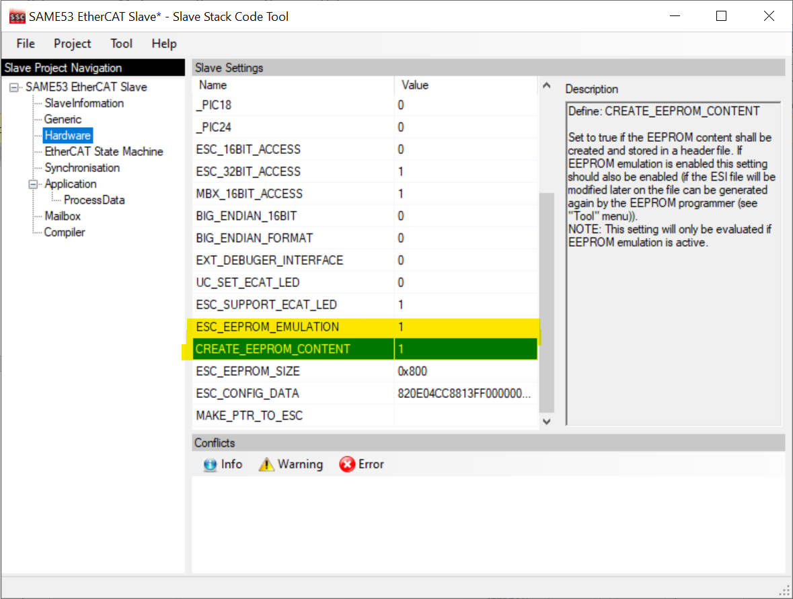

* + The ESC_EEPROM_EMULATION must be 1 and ESC_EEPROM_CONTENT must be 0, while generating SSC code and copy the SSC (Slave stack code) files and place it in SSC folder.

## Version 0.9

|  |  |
| --- | --- |
| Release date | 1/27/2021 |
| **Release Type** | Beta |
| **Pre-requisites (if any)** | No |
| **Source code path** | https://bitbucket.microchip.com/scm/ung_apps/lan9255_firmware_applications.git |
| **Source code label / branch & perforce change list number** | feature/ethercat_uart  Tag: COUNTER_FOE_UART_V0.9 |
| **Software Requirements Specification (SRS) Path and Revision Number** | NA |
| **Software Design Document (SDD) Path and Revision Number** | NA |
| **Software Developer Test Plan (SDTP) Path and Revision Number** | //depot_hw_jutland2_MCM/doc/sw/TestPlan/LAN9255-SAME53-ETHERCAT-COUNTER-FOE_Developer_Test Report.xlsm |
| **Software Requirements Tracker (SRT) Path and Revision Number** | NA |

### Not implemented / Limited functionality requirements

None

### Bug Fixes

### Features added

* J2-SIP-20 – UART application support

### Notes

* The PDI frequency can be selected through the ESF configuration file. The frequency can be given in Mhz to ESF_PDI_FREQUENCY.
* By default, the EEPROM emulation is enabled, can be disabled by commenting **_IS_EEPROM_EMULATION_SUPPORT** macro present in **ESF_Config.h** file.
  + For reference



* **SSC code Generation for EEPROM Emulation mode** – There are two steps to be followed while generating the SSC code for EEPROM Emulation mode and are as follows.
  + The ESC_EEPROM_EMULATION must be 1 and ESC_EEPROM_CONTENT must be 1, while generating SSC code and copy the eeprom.h file and place it in SSC folder.



* + The ESC_EEPROM_EMULATION must be 1 and ESC_EEPROM_CONTENT must be 0, while generating SSC code and copy the SSC (Slave stack code) files and place it in SSC folder.

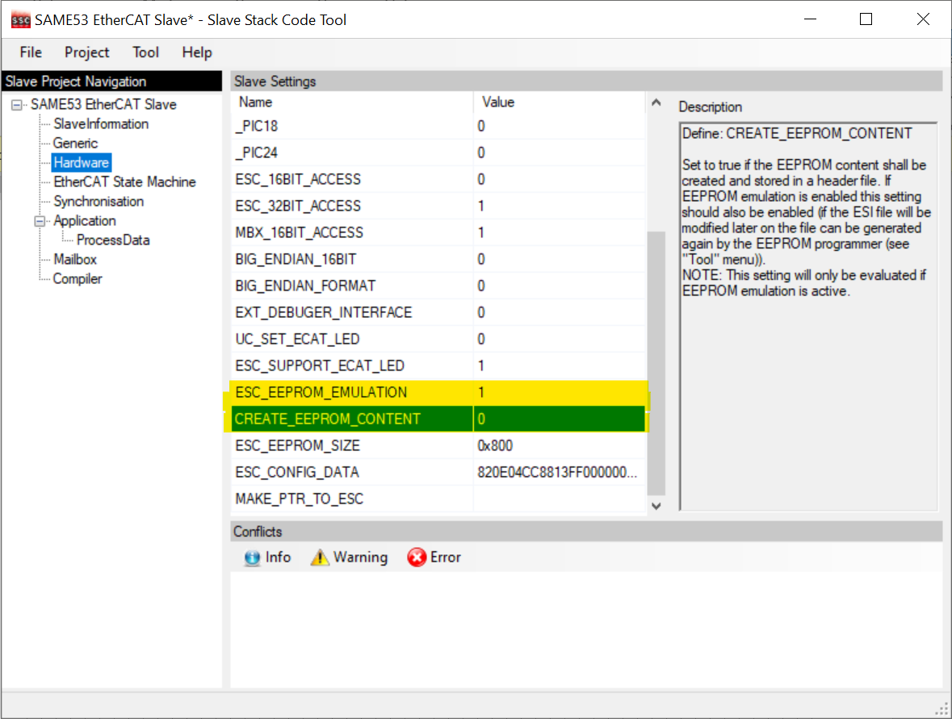

* The UART application is not having any conditional macro. This code can be disabled by using the old Sample_app.xls file while generating SSC code.

## Version 0.8

|  |  |
| --- | --- |
| Release date | 1/7/2020 |
| **Release Type** | Beta |
| **Pre-requisites (if any)** | No |
| **Source code path** | https://bitbucket.microchip.com/scm/ung_apps/lan9255_firmware_applications.git |
| **Source code label / branch & perforce change list number** | bugfix/UNG_J2_SIP-28  Tag: COUNTER_FOE_V0.8 |
| **Software Requirements Specification (SRS) Path and Revision Number** | NA |
| **Software Design Document (SDD) Path and Revision Number** | NA |
| **Software Developer Test Plan (SDTP) Path and Revision Number** | //depot_hw_jutland2_MCM/doc/sw/TestPlan/LAN9255-SAME53-ETHERCAT-COUNTER-FOE_Developer_Test Report.xlsm |
| **Software Requirements Tracker (SRT) Path and Revision Number** | NA |

### Not implemented / Limited functionality requirements

None

### Bug Fixes

* [UNG_J2_SIP-18](https://jira.microchip.com/browse/UNG_J2_SIP-18) - File Over EtherCAT was successful When an Invalid Firmware Bin File is Given as Input File
* [UNG_J2_SIP-28](https://jira.microchip.com/browse/UNG_J2_SIP-28) - EVB_LAN9255_Counter_Direct_Mode_EEPROM_Emulation Firmware did not drive the OLED Display in EVB
* [UNG_J2_SIP-29](https://jira.microchip.com/browse/UNG_J2_SIP-29) - File Over EtherCAT Feature Fails in EVB_LAN9255_Counter_InDirect_Mode_EEPROM_Emulation V0.70 Application

### Features added

* None

### Notes

* The PDI frequency can be selected through the ESF configuration file. The frequency can be given in Mhz to ESF_PDI_FREQUENCY.

## Version 0.7

|  |  |
| --- | --- |
| Release date | 12/11/2020 |
| **Release Type** | Beta |
| **Pre-requisites (if any)** | No |
| **Source code path** | https://bitbucket.microchip.com/scm/ung_apps/lan9255_firmware_applications.git |
| **Source code label / branch & perforce change list number** | feature/ethercat_FOE_counter  Tag: COUNTER_FOE_V0.7 |
| **Software Requirements Specification (SRS) Path and Revision Number** | NA |
| **Software Design Document (SDD) Path and Revision Number** | NA |
| **Software Developer Test Plan (SDTP) Path and Revision Number** | //depot_hw_jutland2_MCM/doc/sw/TestPlan/LAN9255-SAME53-ETHERCAT-COUNTER-FOE_Developer_Test Report.xlsm |
| **Software Requirements Tracker (SRT) Path and Revision Number** | NA |

### Not implemented / Limited functionality requirements

None

### Bug Fixes

* None

### Features added

* Provided OLED support along with counter trigger application. - OLED display will be updated based on counter value as per the update from the master. (TwinCAT).

### Notes

* The PDI frequency can be selected through the ESF configuration file. The frequency can be given in Mhz to ESF_PDI_FREQUENCY.

## Version 0.51

|  |  |
| --- | --- |
| Release date | 12/1/2020 |
| **Release Type** | Beta |
| **Pre-requisites (if any)** | No |
| **Source code path** | https://bitbucket.microchip.com/scm/ung_apps/lan9255_firmware_applications.git |
| **Source code label / branch & perforce change list number** | feature/ethercat_FOE_counter  Tag: COUNTER_FOE_V0.51 |
| **Software Requirements Specification (SRS) Path and Revision Number** | NA |
| **Software Design Document (SDD) Path and Revision Number** | //depot_hw_jutland2_MCM/doc/sw/EVB_LAN9255_Counter_FoE Design.docx |
| **Software Developer Test Plan (SDTP) Path and Revision Number** | //depot_hw_jutland2_MCM/doc/sw/TestPlan/LAN9255-SAME53-ETHERCAT-COUNTER-FOE_Developer_Test Report.xlsm |
| **Software Requirements Tracker (SRT) Path and Revision Number** | NA |

### Not implemented / Limited functionality requirements

None

### Bug Fixes

* [UNG_J2_SIP-14](https://jira.microchip.com/browse/UNG_J2_SIP-14) - [ETG Compliance Failure]: Failed in PDI Error Counter test

### Features added

* None

### Notes

* The PDI frequency can be selected through the ESF configuration file. The frequency can be given in Mhz to ESF_PDI_FREQUENCY.

## Version 0.5

|  |  |
| --- | --- |
| Release date | 9/29/2020 |
| **Release Type** | Beta |
| **Pre-requisites (if any)** | No |
| **Source code path** | https://bitbucket.microchip.com/scm/ung_apps/lan9255_firmware_applications.git |
| **Source code label / branch & perforce change list number** | feature/ethercat_FOE_counter  Tag: COUNTER_FOE_V0.5 |
| **Software Requirements Specification (SRS) Path and Revision Number** | NA |
| **Software Design Document (SDD) Path and Revision Number** | //depot_hw_jutland2_MCM/doc/sw/EVB_LAN9255_Counter_FoE Design.docx |
| **Software Developer Test Plan (SDTP) Path and Revision Number** | //depot_hw_jutland2_MCM/doc/sw/TestPlan/LAN9255-SAME53-ETHERCAT-COUNTER-FOE_Developer_Test Report.xlsm |
| **Software Requirements Tracker (SRT) Path and Revision Number** | //depot_hw_jutland2_MCM/doc/sw/LAN9255_CrossFunctional_ProjectPlan.mpp |

### Not implemented / Limited functionality requirements

None

### Bug Fixes

* [UNG_JUTLAND2-278](https://jira.microchip.com/browse/UNG_JUTLAND2-278) - Odd address read with any length is failing in ESF - SQI mode
* [UNG_JUTLAND2-279](https://jira.microchip.com/browse/UNG_JUTLAND2-279) - PDRAM write is failing in Indirect mode - ESF SQI Interface

### Features added

* [UNG_J2_SIP-5](https://jira.microchip.com/browse/UNG_J2_SIP-5) - FOE support in EVB LAN9255 - Jutland II SIP firmware

Provide support to firmware upgrade through FOE via master.

* [UNG_J2_SIP-3](https://jira.microchip.com/browse/UNG_J2_SIP-3) - Integrate ESF SAME53 code into EtherCAT Counter FOE firmware. EtherCAT Counter FOE firmware is targeted for LAN9255 Jutland II SIP. Integrate/Port already available SAME53 SQI code into EtherCAT Counter FOE firmware application.
* [UNG_J2_SIP-4](https://jira.microchip.com/browse/UNG_J2_SIP-4) - LAN9255 Counter FOE firmware - PCLint setup with MISRA 2012 standard.
* [UNG_J2_SIP-2](https://jira.microchip.com/browse/UNG_J2_SIP-2) - Boot loader support for FOE Jutland II SIP firmware.

### Notes

* The PDI frequency can be selected through the ESF configuration file. The frequency can be given in Mhz to ESF_PDI_FREQUENCY.